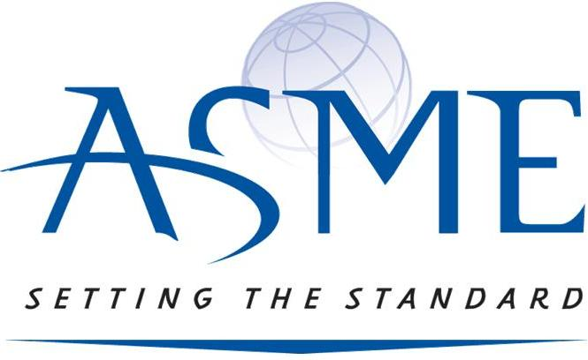
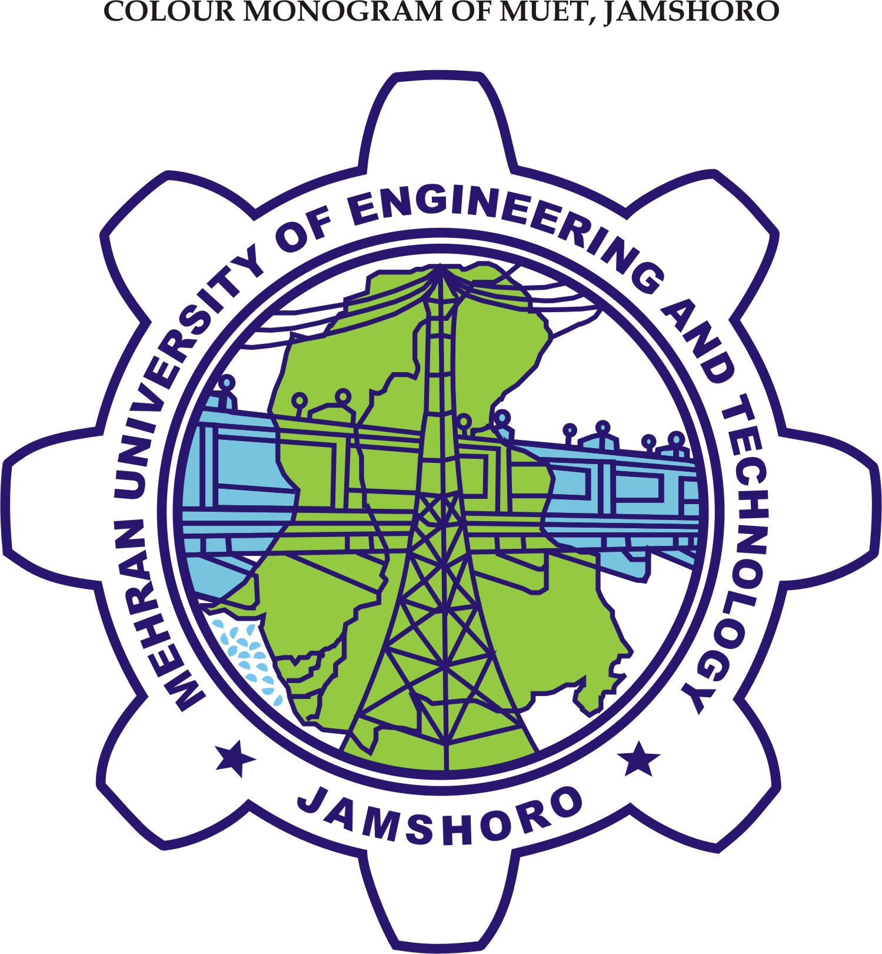

DEPARTMENT OF MECHANICAL ENGINEERING
MUET Jamshoro

Is Organizing a Seminar
On
Finite Element Method (FEM) & Computational Fluid Dynamics (CFD)

Guest Speakers are,

Mr. Amir Khan
(M.Sc. Computational Engineering, Ruhr University, Bochum Germany)

Mr. Shamoon Jamshed
(M.Sc. Computational Fluid Dynamics, Cranfield University, England)

On 3rd April, 2010, Time: 11.00 a.m.
Venue: MUET AUDITORIAM

For details and registration contact
Shamsul Arfeen (07ME03), Chair ASME – MUET Chapter, 03003223088
Rabi-ul-Haq (07ME105), Vice Chair ASME – MUET Chapter, 03322634220

