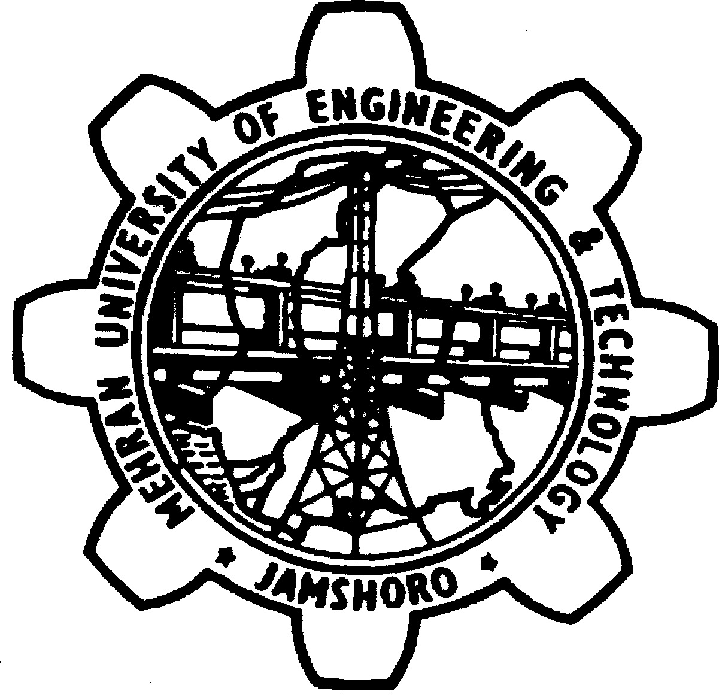
MEHRAN UN IVERSITY OF ENGINEERING & TECHNOLOGY, JAMSHORO

FOR MEHRAN UNIVERSITY OF ENGINEERING AND TECHNOLOGY, JAMSHORO

POST | QUALIFICATION / EXPERIENCE
Lecturer  (Petroleum & Natural Gas Engg)  BPS-18 | 1st Class B.E. or equivalent degree awarded after 16 years of education in the relevant field with no 3rd division in the academic career from HEC recognized University / Institution.  The preference will be given to those who have completed the M.Phil / Master Degree (18 years education) from HEC recognized University.  The applicant(s) must have valid GRE general type at their credit, with minimum of 50 score conducted by National Testing Service (NTS).

S# | Name and father’s name | Valid GRE Score minimum  50
 | Shoaib S/o Shoukat ali Memon | 55
 | Waqar Hussain S/o Dr. Abdul Sattar Buriro | 54
 | Muhammad Ali S/o Muhammad Irfan Buriro | 74
 | Muhammad Mubeen-ur-Rehman S/o Asghar Ali Arain | 61
 | Habib-u-Zaman S/o Muhammad Saleh Memon | 58
 | Mujahid Ali S/o Shoukat Ali Qureshi | 67
 | Muhammad Anees S/o Ghulam Muhammad Memon | 62
 | Arshad Ahmed S/o Ghulam Nabi Lashari | 58
 | Darya Khan S/o Khalid Mian Bhutto | 69
 | Zeeshan Ali S/o Mohammad Muneer Lashari | 51
 | Abdul rauf S/o Raza Muhammad Channa | 54
 | Muhsin Ali S/o Ali gul abbasi | 54
 | Masood Ahmed S/o Meer Muhammad Siyal | 50
 | Omair Khan S/o Mehar Rind Baloch | 63
 | Zaheer Ahmed S/o Habibullah Jamali | 62
 | Jan Muhammad S/o Mohammad Essa Jarwar | 55
 | Ali Naqi S/o Zaheer Abbas Syed | 54
 | Muhammad Nisar S/o Said Majeed Khan | 70

