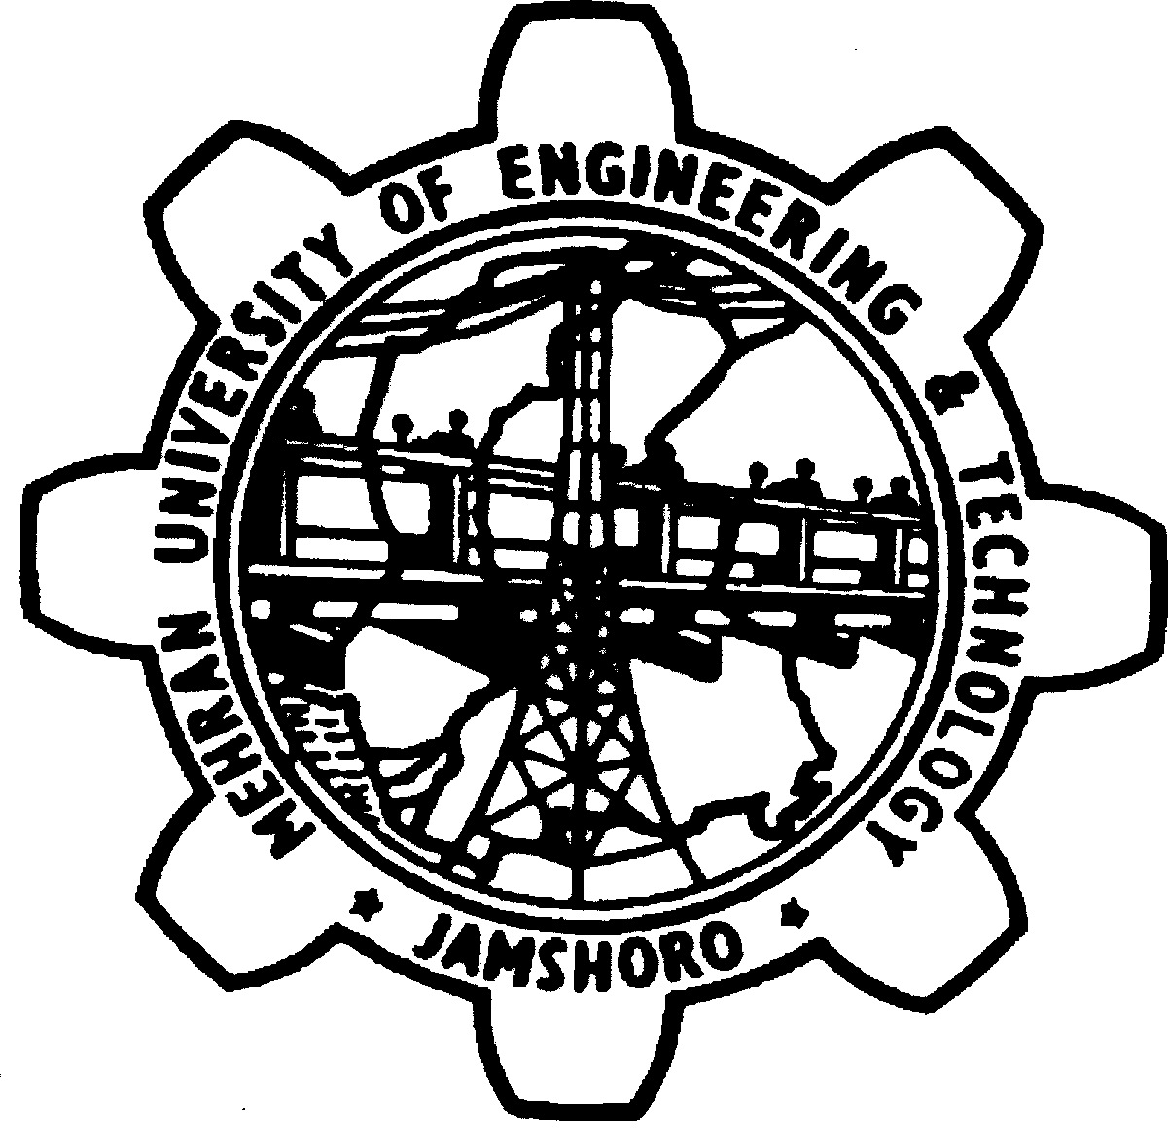
MEHRAN UN IVERSITY OF ENGINEERING & TECHNOLOGY, JAMSHORO

FOR MEHRAN UNIVERSITY OF ENGINEERING AND TECHNOLOGY, JAMSHORO

POST | QUALIFICATION / EXPERIENCE
Lecturer  (Industrial Engg & Mgt)  BPS-18 | 1st Class B.E. or equivalent degree awarded after 16 years of education in the relevant field with no 3rd division in the academic career from HEC recognized University / Institution.  The preference will be given to those who have completed the M.Phil / Master Degree (18 years education) from HEC recognized University.  The applicant(s) must have valid GRE general type at their credit, with minimum of 50 score conducted by National Testing Service (NTS).

S# | Name and father’s name | Valid GRE Score minimum  50
A | B | F
 | Zuhair Ali S/o Muhammad Bux Bhatti | 51
 | Ali Arsalan S/o Prof. Moinuddin siddiqui | 50
 | Muhammad Saad S/o  Hafiz Abdul Haque Memon | 57
 | Adnan Ali S/o Syed Muzaffar Ali Syed | 54
 | Mohsin Azeem S/o Azam Khan Lodhi Pathan | 50

