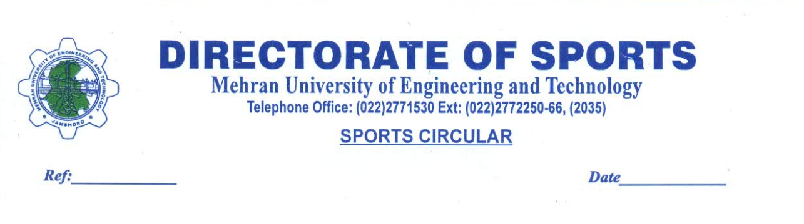
“SAY NO TO CORRUPTION”

No. & Dated: MUET/DS/16/2020, 10-01-2020
REQUEST FOR QUOTATION

Description : RFQ for Providing of Panaflex Banners and Flags.
Date of Issuance : 13-01-2020 to 21-01-2020
Date of Submission of Quotation : 22nd January, 2020 upto 10:30 A.M in the office of undersign
Date of Opening of Quotation : 22nd January, 2020 @ 11.00 A.M in the office of undersign
Place of Delivery : MUET, Jamshoro.
Contact Person and No. : Mr. Abdul Fatah Kandhir, 0300-3790515.

All the interested Contractors / Firms / Parties / Suppliers, Manufacturers and Sole Distributors meeting eligibility criteria, viz. having registration with Federal Board of Revenue (FBR) for Income Tax, Sales Tax are invited to participate in full / item rate quotation for the following works:

S# | Description | Unit | Quantity | Rate | Amount
1. | Panaflex Banners (Size 8*25). | Nos. | 02
2. | Panaflex Banners (Size 5*10). | Nos. | 08
3. | Flags (Different Colors size 3*5) | Nos. | 36

The terms and conditions are given as under:-

- The Registration certificate (FBR and or SRB) must be provided at the time of submission.
- The quoted amount must be included all the applicable taxes.

- The Procuring Agency reserves the right to cancel or reject any or all quotations.
- Payment will be made through crossed cheque after the receipt of the bill and satisfactory performance certificate.

- The rate / item cost must be quoted for all required items otherwise incomplete or conditional quotation will not accepted.

- The rate / items cost is final and no change what so ever will be accepted.

- The Procuring Agency reserves the right to change / alter / remove any item or article or reduce / enhance quantity as per rules without assigning any reason.

- No subletting in any case will be allowed.

- Stamp Duty @ rate of 0.35 % of total value of goods will be fixed accordingly.

- The Procuring Agency reserves the right to issue Purchase Order for any single item(s) to different lowest responsive bidders or issue Purchase Order for all the items to any lowest responsive bidder.

Deputy Director Sports,
Mehran University of Engg. & Tech. Jamshoro,
Phone No. 022-2772253 (2035)

MEHRAN UNIVERSITY OF ENGINEERING & TECHNOLOGY, JAMSHORO

SPORTS WEEK 2020

W.E.F 04TH TO 07TH FEBRUARY 2020

BOY’S EVENT GIRL’S EVENT

Mini Marathon Mini Marathon
Tug of War Tug of War
Cricket Throw Ball
Volley Ball Table Tennis
Table Tennis Cricket
Squash Badminton
Badminton Chess
Chess Sack Race
Sack Race
Kabbadi

ORGANIZED BY
DIRECTORATE OF SPORTS

(Sample For Writing On Panaflex)

